Supplementary Materials

Parameter Recovery

We tested whether parameters could be accurately recovered from our models. We configured theoretical parameters and produced simulated choices for the cutoff, cost to sample, biased prior and two other models, the biased values and biased reward models (described below). We simulated data for 12 configured parameter values (the x axis of Figure S1 and the bar heights in Figure S2, upper panel, show these values) chosen to produce, as close as possible, the entire span of sampling rates (Figure S2 upper panel and Figure S3 x axes show the span of these simulated sampling rates). For each configured parameter value, we simulated a sample of 20 “participants” (about the same sample size of one of the smaller *N* datasets examined herein). For each simulated participant, a participant-specific generating distribution was created by sampling 426 values (the same number of phase 1 items in many of the studies herein) from a normal distribution bounded between 1 and 100 with a mean of 40 and a standard deviation of 20 (which roughly approximates the moments of participants’ empirical phase 1 ratings distributions). Then, five sequences (the smallest number of sequences per participant of the datasets examined herein) of eight option values each were populated by sampling without replacement from each simulated participant’s individual generating distribution. The mean and standard deviation of each participant’s generating distribution were used to define the prior generating distribution in both the configured parameter models and the fitted models. The corresponding model was then fitted to these simulated data and the estimated parameter and its associated sampling rate were compared with the original configured parameter and its associated sampling rate.

The fitted cost to sample, cut off and biased prior models roughly reproduced the sampling rates (see Figure S2, middle panel) of their preconfigured counterparts (Figure S2, upper panel). The biased values and biased reward models however appear unable to achieve mean sampling rates higher than about four samples per sequence. Individual participant sampling rates associated with configured and estimated parameters correlated well for the cost to sample, cut off and biased prior models, but less so for the biased values and biased reward models (Figure S3). Correlations of configured and estimated parameters were nearly perfect for the cost to sample and biased prior models and tolerable for the cut off model, though they were unacceptably low for the biased values and biased reward models (Figure S1).

Because the biased values and biased reward models showed relatively low correlations between configured and estimated parameters, they were excluded from the formal model comparison reported in the Results. Descriptions of the models that were retained for further analysis, cost to sample, cut off and biased prior models, are provided in the Introduction and Methods. Here, we briefly describe the two models and that were rejected based on the parameter recovery results. The *biased values model* transforms the option values before they are put into the ideal observer by setting option values below a threshold to 1 and above that threshold to 100. The threshold was the key theoretical free parameter. The biased values was motivated by “high threshold” models of mate choice in behavioural ecology (Valone et al., 1996), where animals reject all potential mates only until encountering one with attractiveness above a high threshold. The threshold parameter was initialised to 50 and bounded between 1 and 100. The *biased reward model* was based on the same idea as BV, except that the threshold transformation was applied to the reward values assigned to the relative ranks in each sequence. Option values above the parameterised threshold value were assigned a reward value of 100 and values below that threshold were assigned a reward value of 0. The threshold parameter was initialised to 50 and bounded between 1 and 100.

Figure S1. We examined parameter values (vertical axes) estimated from fitting models to decisions simulated using configured parameter values (horizontal axes) for 20 simulated participants (each shown as an individual scatter point) per simulated parameter level. The grey diagonal indicates when configured and estimated parameters would be exactly equal. The coloured line indicates the regression line relating configured and estimated parameter values. biased values and biased reward models showed too poor parameter recovery to be entered into formal model comparison.

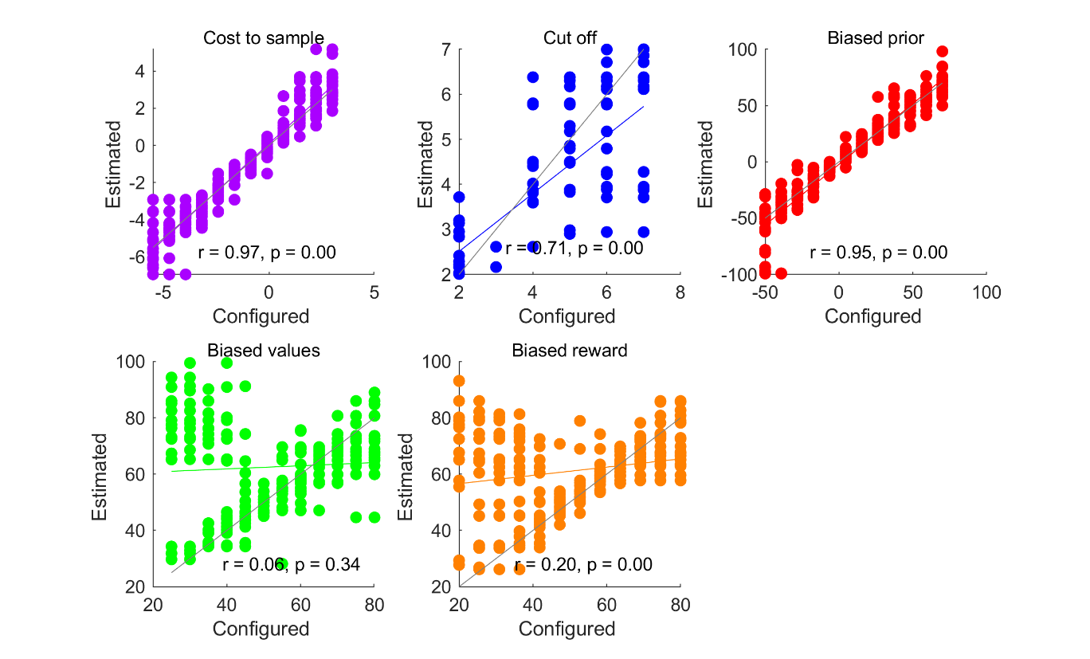

Figure S2. Top panel: We plot sampling rates for individual simulated participants (points) and their mean values (bars) for each configured parameter level in the parameter recovery analysis. Systematically varying configured parameter values successfully increases or decreases simulated sampling rates for cost to sample, cut off and biased prior models. Middle panel: Models were fitted to the data in the top panel and parameters estimated. We plot the sampling rates simulated using each estimated parameter (points) and their mean sampling rates (bars). Lower panel: The estimated parameters (points) are plotted relative to their target configured parameter values (bars). Each model’s parameter values are normalised to a 0 to 1 range to facilitate plotting on one scale.

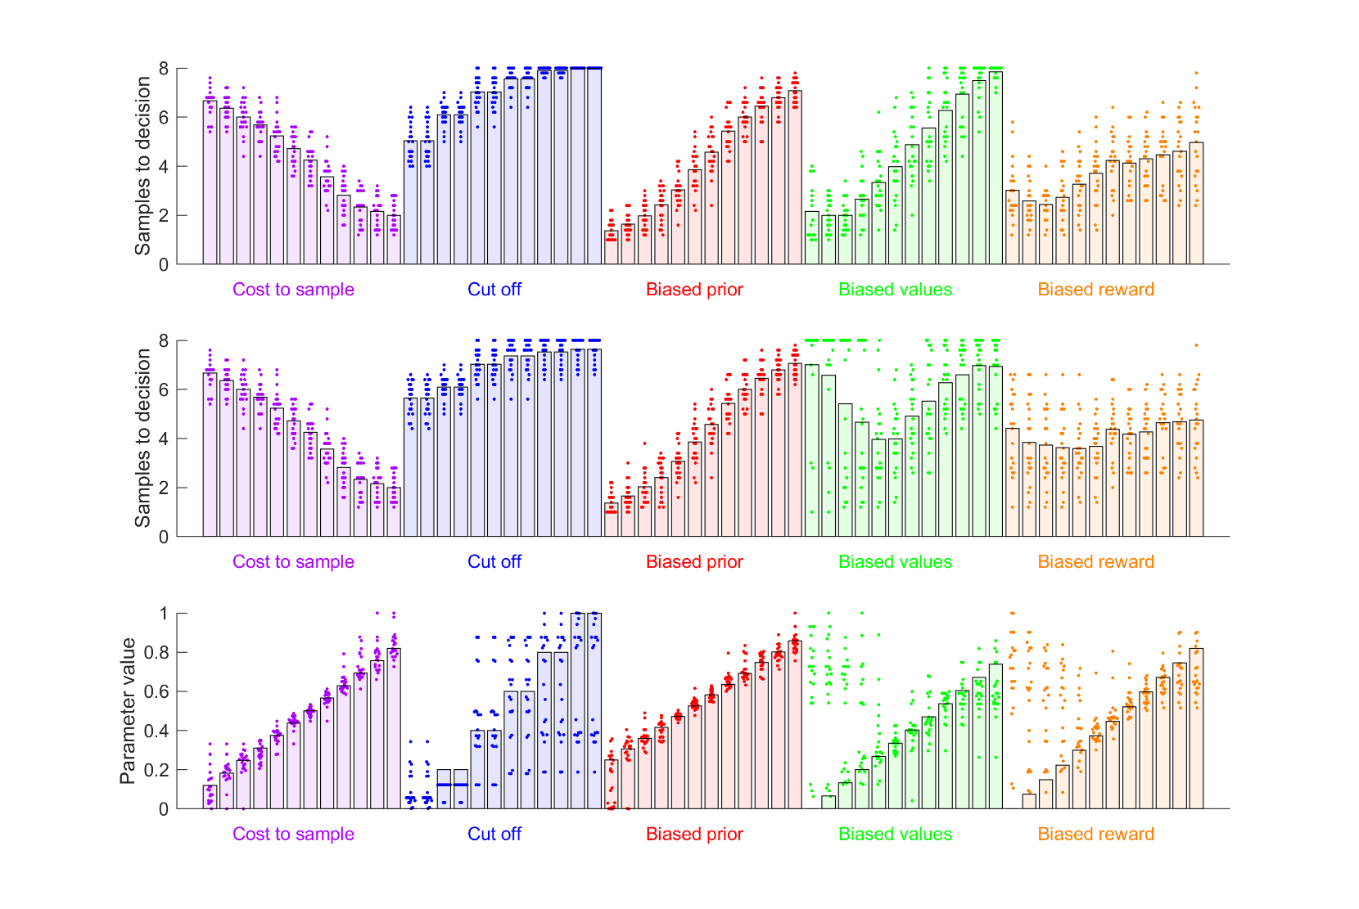

Figure S3. Sampling rates simulated using configured parameters (horizontal axis) are plotted against sampling rates computed from estimated parameters. The grey diagonal indicates when sampling rates based on configured and estimated parameters would be exactly equal. The coloured line indicates the regression line relating sampling rates based on configured and estimated parameter values.

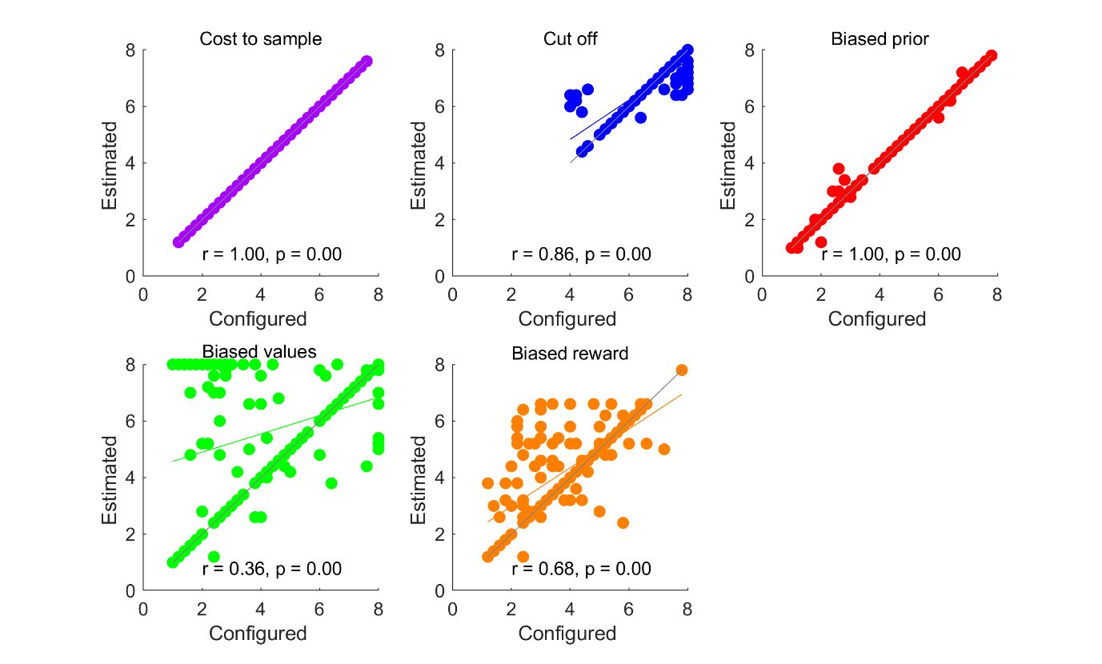

Figure S4. Model comparison for facial attractiveness datasets 1 (left column), 2 (centre column) and 3 (right column). Top and middle rows show data corresponding to individual participants as points and bars show their mean values. The top row shows the ranks of chosen items. The second row plots the “first” or key theoretical parameter values, estimated for each fitted model. The third row shows the “second”, or inverse temperature parameter beta, estimated for each fitted model.

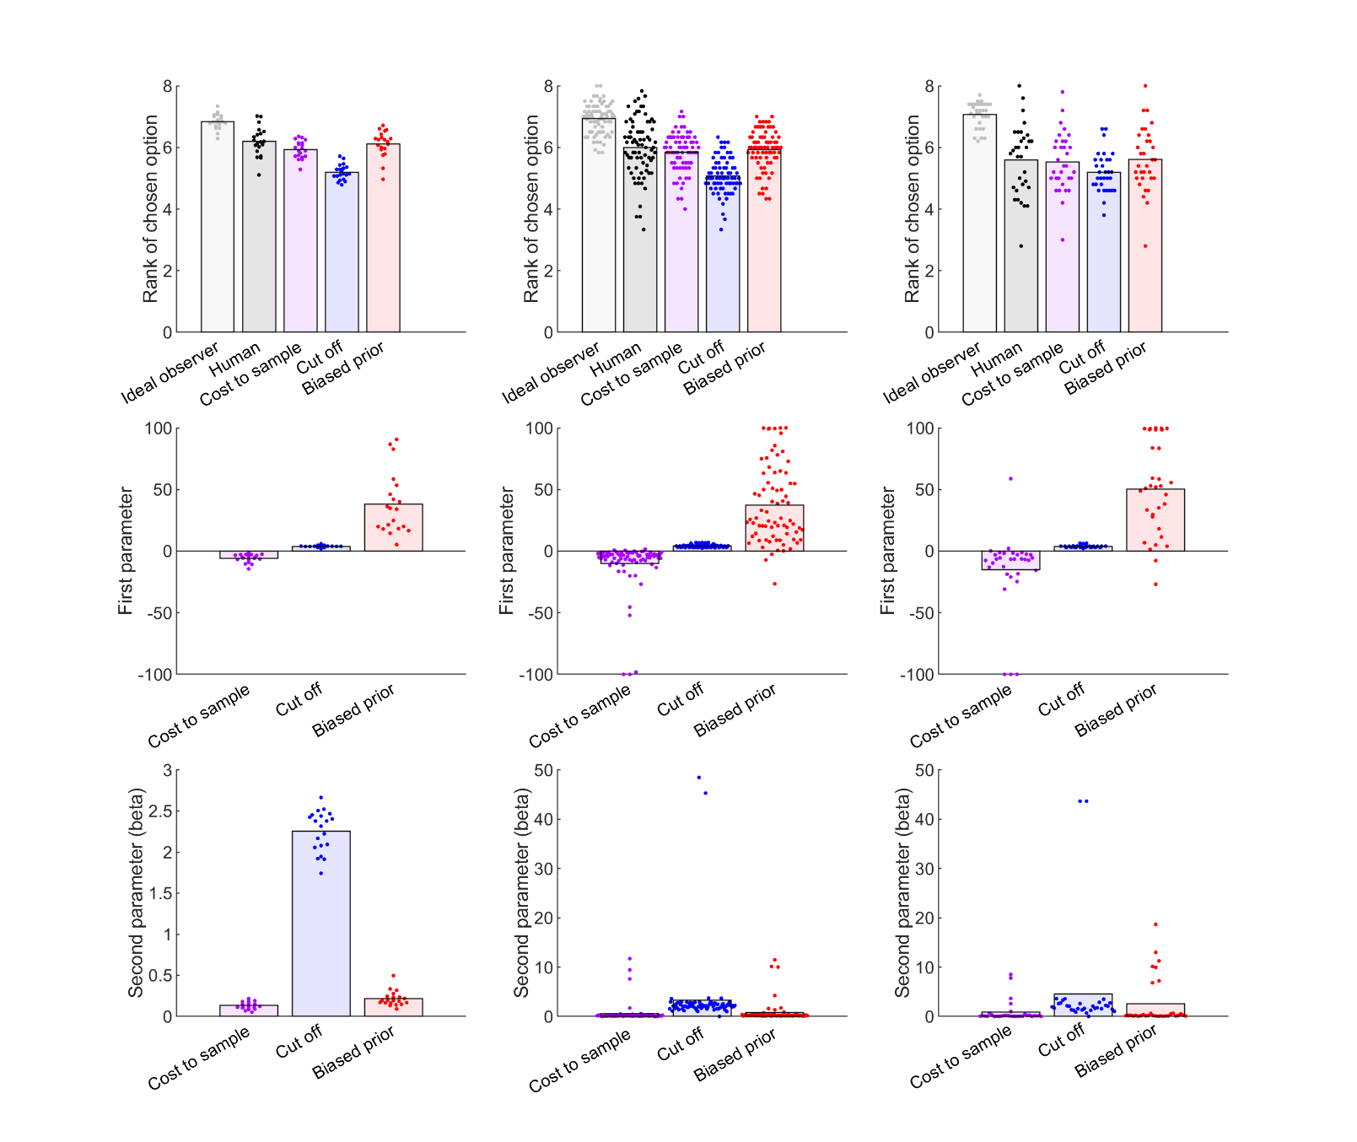

Figure S5. Model comparison for matchmaker dataset (left column), trustworthiness dataset 1 (centre column) and trustworthiness dataset 2 (right column). Top and middle rows show data corresponding to individual participants as points and bars show their mean values. The top row shows the ranks of chosen items. The second row plots the “first” or key theoretical parameter values, estimated for each fitted model. The third row shows the “second”, or inverse temperature parameter beta, estimated for each fitted model.

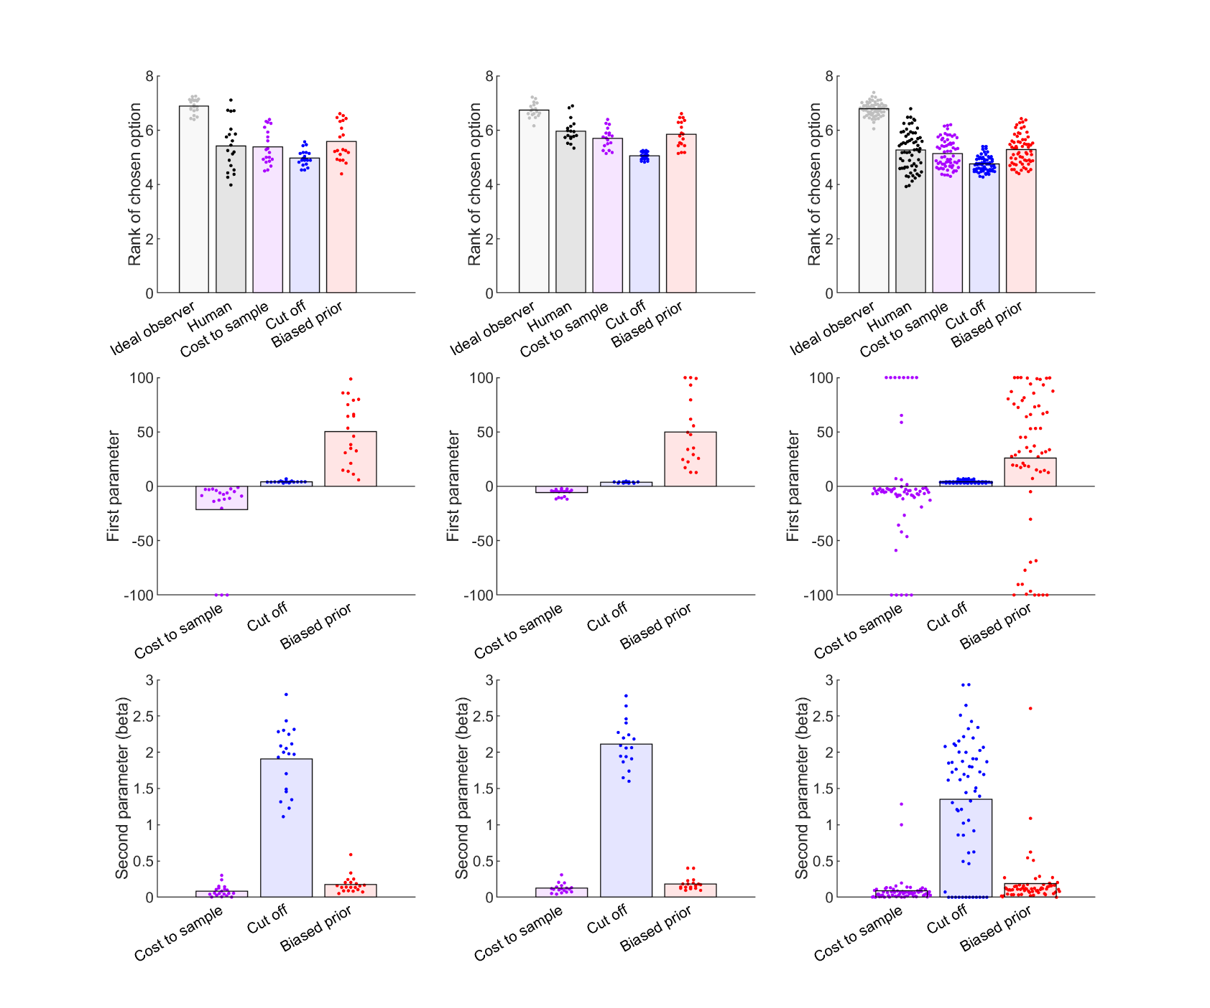

Figure S6. Model comparison (columns from left to right): foods datasets 1 and 2, vacations datasets 1 and 2. Top and middle rows show data corresponding to individual participants as points and bars show their mean values. The top row shows the ranks of chosen items. The second row plots the “first” or key theoretical parameter values, estimated for each fitted model. The third row shows the “second”, or inverse temperature parameter beta, estimated for each fitted model.

